­ 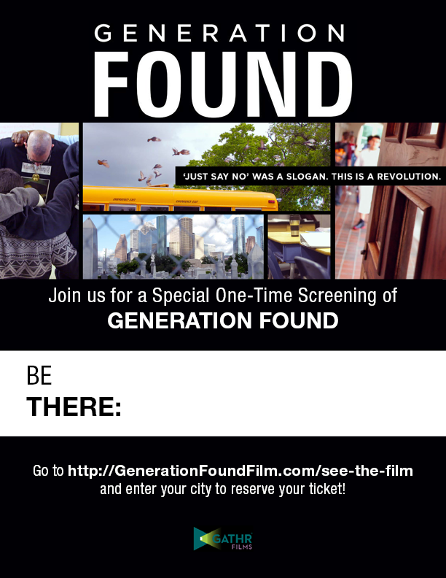

**Thursday, October 27th** 6:00 PM Doors Open!

Producer, **Greg Williams** will speak @ **6:15**; Film begins at **7:00 PM**

Munson Williams Proctor Arts Institute

Tickets **$14** via **http://bit.ly/2dw9Bfa**