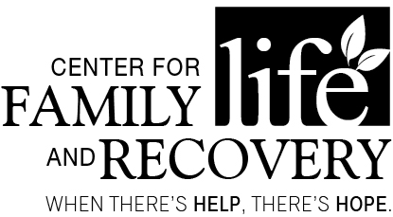

In partnership with the Professional Training Coalition of Oneida County

TRAINING OPPORTUNITY
“Substance Use Issues and Working With Law Enforcement”
With Jermaine Galloway
DATE: August 19, 2016

TIME: 9:00am-4:00pm (registration at 8:30am)

PLACE: Hart’s Hill Inn, Whitesboro, NY
COST: $55 (includes morning coffee set-up, lunch and materials)

OASAS:
6 Hours
CASAC
Renewal Only
CPP/CPS
Section: pending

Working with Law Enforcement: The Bridge of Collaboration
This class teaches educators, community members, and coalitions the methods of working with law enforcement in their community. Includes pro-active approaches to gain leverage with your local police department or sheriff's office. Stresses the importance of working together.
Professional
Training Committee

Susan Calandra
Susan Koniewicz-
Everett
Rebecca King
Colleen Callaghan-Kirkland
Shawn Luther
Holly Matthews
Kenan Raeljas
Judith H. Reilly
Sarah Rorick
Steve Smith
Denise Spagnola
Sara Wolven

Who should attend:
Social Workers, Addiction Treatment and/or Prevention Professionals, Case Managers, Residential Providers, Parole and Probation Staff, Law EnforcementSchool Counselors, Marriage and Family Therapists and others serving individuals with co-occurring psychiatric and substance use disorders.

Training Date/Title: “Substance Use Issues and Working With Law Enforcement”
REGISTRATION DEADLINE: August 12, 2016

Name: _____________________________________________ Position: __________________________________
Agency/Employer: _________________________________ Street: _________________________________________
City: _____________ Zip: _____________ Phone: (_____) ______________ Email: ___________________________
TO REGISTER BY Mail Only: Return form with non-refundable registration fee to: CFLR Attention: Charmaine Rosado, 502 Court Street, Suite 401, Utica, NY 13502. **Registration confirmation will not be sent. Participants are considered registered when payment or P.O. number is received. Receipts for payment are available please indicate on the form if a receipt is needed. P.O.s are accepted. You can pay online at www.cflrinc.org! Questions? Please contact Charmaine via email: crosado@cflrinc.org
Sponsored by Oneida County
Department of Mental Health

