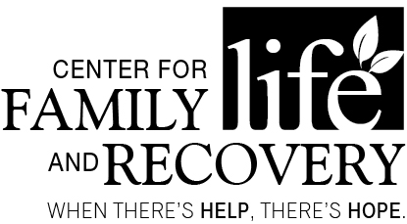

In partnership with the Professional Training Coalition of Oneida County

TRAINING OPPORTUNITY
“Drug Trends and Working with Law Enforcement”
With Jermaine Galloway
DATE: November 4, 2016

TIME: 9:00am-2:00pm (registration at 8:30am)

PLACE: Hart’s Hill Inn, Whitesboro, NY
COST: $55 (includes morning coffee set-up, with a work through lunch and materials)

OASAS:
6 Hours
CASAC
Renewal Only
CPP/CPS
Section: pending

Drug Trends & Working with Law Enforcement
This creative and informative training will cover collaborations of working with local law enforcement through the training of drug and alcohol trends, logos, terms and identifiers. Also, discussed will be current hurdles for law enforcement and how todays evolving drug and alcohol culture can be impacted and reduced through training.
Professional
Training Committee

Susan Calandra
Jim Davis
Colleen Callaghan-Kirkland
Shawn Luther
Holly Matthews
Heather Perry
Kenan Raeljas
Judith H. Reilly
Sarah Rorick
Steve Smith
Denise Spagnola
Sara Wolven

Who should attend:
Social Workers, Addiction Treatment and/or Prevention Professionals, Case Managers, Residential Providers, Parole and Probation Staff, Law Enforcement, School Counselors, Marriage and Family Therapists and others serving individuals with co-occurring psychiatric and substance use disorders.

Training Date/Title: “Drug Trends and Working with Law Enforcement”
REGISTRATION DEADLINE: October 31, 2016

Name: _____________________________________________ Position: __________________________________
Agency/Employer: _________________________________ Street: _________________________________________
City: _____________ Zip: _____________ Phone: (_____) ______________ Email: ___________________________
TO REGISTER BY Mail Only: Return form with non-refundable registration fee to: CFLR Attention: Heather Perry, 502 Court Street, Suite 401, Utica, NY 13502. **Registration confirmation will not be sent. Participants are considered registered when payment or P.O. number is received. Receipts for payment are available please indicate on the form if a receipt is needed. P.O.s are accepted. You can pay online at www.cflrinc.org! Questions? Please contact Heather via email at hperry@cflrinc.org
Sponsored by Oneida County
Department of Mental Health

