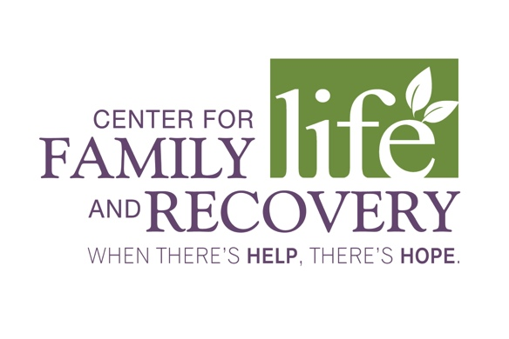

**20th Annual April Awareness Breakfast**

**2018 Amethyst Award Form**

The 2018 Amethyst Award will be presented to a member of our community who has helped others by inspiring them with the message of hope and recovery in the fields of mental health and chemical dependency, as well as their treatment and prevention. The 2018 recipient will be honored at the **20th Annual April Awareness Breakfast on Tuesday, April 3, 2018 at 8:30 A.M., at Daniele’s Banquet Specialists on Seneca Turnpike in New Hartford.**

Please use this form to nominate an individual that you believe is most deserving of this year’s award.

Nominee’s Full Name (Print): ____________________________________________________________  
Nominee’s Agency/Company Name: _______________________________________________________  
Nominees Phone:____________________ Nominee’s Email:___________________________________  
Nominated By (Full Name): ______________________________________________________________  
Agency/Company Name: ________________________________________________________________   
Phone: __________________________ Email: _______________________________________________

Briefly describe the reason/s for your nomination (Please use the back of this form, if necessary):

_____________________________________________________________________________________________

_______________________________________________________________________________________________________________________________________________________________________________________________________________________________________________________________________________________

____________________________________________________________________________________________________________________________________________________________________________________________________________________________________________________________________________________________________________________________________________________________________________

_____________________________________________________________________________________

_____________________________________________________________________________________

____________________________________________________________________________________

Please send the completed form to Bianca Bussey, bbussey@cflrinc.org by 12 P.M. on February 28.

For questions, please call CFLR, Inc. at (315) 733-1709. Remember, When There’s Help, There’s Hope.