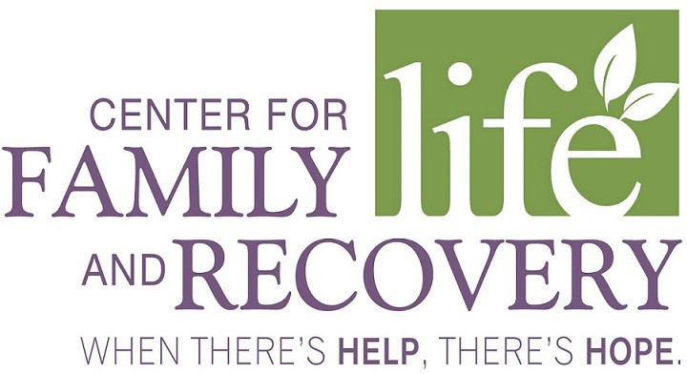

2020 Professional Training Schedule
Month | Date/Time | Training | Trainer | Fee | Location
January
February | 7th (8:30-3:30) | Workplace Wellness Expo  Self-care and Burn out Prevention  We will be rescheduling soon | Christina D’ Amico, Angelica Martin, Jennifer D’ Amico and Crystal Faria | $75 | Harts Hill
March | 16th (8:30-4) | Professional Growth and Development Skill Building: It’s Reciprocal | Lila Boyer and Ambi Daniel | $60 | CFLR
 | 17th-18th (8:30-5) | Ethical Consideration for Recovery Coaches | Lila Boyer and Ambi Daniel | $200 | CFLR
 | 30th-31st (8:30-4) | Peer Professional Supervision | Ambi Daniel | $200 | CFLR
April | 24th (8:30-4) | Post-Partum Depression  Miscarriage Grief | James Davis, LMHC and Linda Zelows, LCSW-R | $60 | CFLR
May |  | Trainings to be decided
June | 12th (8:30-4) | Boundaries Setting – Self Help  Vicarious Trauma | James Davis, LMHC and Linda Zelows, LCSW-R | $60 | CFLR
July | 9th (8:30-4) | Social Determinacy in Care | Laura Langner |  | CFLR
 | TBD | Ethics Training | Lee Livermore | $60 | CFLR
August | TBD | Prevention and Vaping | Jodi Warren | $60 | CFLR
September | 24th -25th (8:30-4) | Motivational Interviewing I | Denise Spagnola and Bonnie Carr | $150 | CFLR
October | 22nd-23rd | Motivational Interviewing II | Denise Spagnola and Bonnie Carr | $150 | CFLR
November | TBD | Alphabet Soup – Therapy Modalities | Ambi Daniel | $60 | CFLR

To sign up for Trainings please go to www.whenthereshelpthereshope.com or call 315-733-1709

