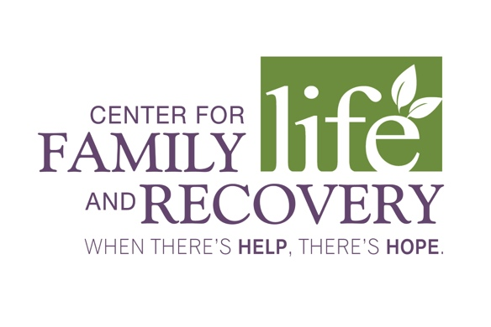

June 28, 2018

Center for Family Life and Recovery, Inc. Board of Directors

RESOLUTION
At the meeting of the Board of Directors of Center for Family Life and Recovery, Inc. on June 28, 2018, the following resolution was proposed and approved by the board of Directors.

Whereas the restricted funds are each less than $100,000 in balance, were donated more than 20 years ago and the donors are no longer available,

Whereas a letter was sent to Attorney General Eric T. Schneiderman on February 22, 2018 per the directions for the Release of Donor-Imposed Restrictions on Management, Investment, or Purpose of an Institutional Fund (N-PCL 554(e), from A Practical Guide to the New York Prudent Management of Institutional Funds Act,

Whereas more than the required 90 days have passed and no response has been received from the Attorney General to date,

Whereas the reallocation of the funds will be made in a manner consistent with and closest to the original intent of the funds,

RESOLVED:

WHEREAS the change of restricted funds of E.M. Rose ($56,452.93), M. Marietta ($38,756.27), and Eleanor Walsh Wertimer Endowment ($45,613.70) totaling $140,822.90 as of May 30, 2018 will be restricted to the following funds:

Compeer funds – $30,000 + 6,792 (current balance) = $36,792.00.

Recovery funds - $110,822.90 – this newly constructed fund is to support the vision and mission of the organization which is; to create a community that sustains recovery by transforming the lives of individuals and families by providing help and hope through advocacy, prevention, counseling and training.

Signed: _____________________________________
Kelly Walters, President

Signed: ______________________________________
Terry Plizga, Secretary

