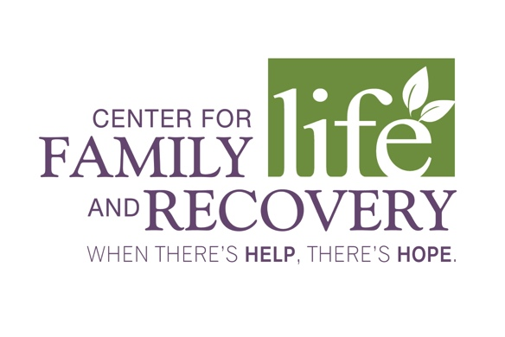

CARE MANAGER

Reports to: Senior Care Manager
Employment Status: Non-Exempt Full Time

JOB DESCRIPTION: Care Manager is responsible for coordinating all health and social service needs for Medicaid and Non Medicaid eligible individuals with multiple chronic conditions, serious mental illness and/or substance abuse disorders. Working as part of a Care Team, the Care Manager collaborates with health professionals and caregivers to ensure individuals have the proper supports in place to stay healthy. Flexibility and good communication skills required. Must have knowledge of community resources and valid driver’s license and transportation.

REQUIRED QUALIFICATIONS: Bachelor’s Degree in Social Work, Psychology, Nursing (RN), Rehabilitation, Education, OT, PT, counseling or other human services field, CASAC, or a NYS Teachers Certificate. When designated as a Children’s Care manager or a High Risk Care Manager two years of Human service experience in providing direct services and linking people with serious mental illness, developmental disabilities, or substance use disorders to a broad range of services.

SPECIFIC RESPONSIBILITIES INCLUDE:
- Serves as an advocate, facilitator, monitor, supporter and primary resource and referral agent for assigned clients.
- Maintains and enhances the quality of life and prevents psychiatric hospitalizations by reducing the stresses in community life.
- Implements the principles of psychiatric rehabilitation by encouraging the empowerment of each individual.
- Conducts individual assessments and develops of an individualized service plan.
- Encourages participation in appropriate programming services and provides assistance as needed.
- Assists individuals in recognizing how services may alleviate problems and help them achieve their objectives.
- Assists clients in exercising better judgment skills through supportive monitoring.
- Supports and encourages clients as they attempt to adjust to new services.
- Links clients by arranging appointments with service providers and facilitating the receipt of such services.
- Reports crisis situations and utilizes Crisis Services when set-backs indicate the need for assessment and/or stabilization.
- Adheres to the guidelines and procedures as established by the Office of Mental Health (OMH) and Medicaid for CM Program.
- Maintains self in professional manner at all times, adhering to Neighborhood Center policy, procedures and in keeping with the Agency’s mission statement.
- Performs other duties as requested by Agency Administration.

Employee Signature: ______________________________________ Date_______________

CEO Signature: __________________________________________ Date_______________

In support of the Americans with Disabilities Act, this job description lists only those responsibilities and qualifications deemed essential to the position. Equal Opportunity Employer.

