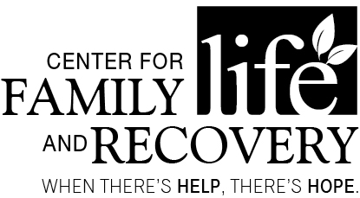

In partnership with the Professional Training Coalition of Oneida County

TRAINING OPPORTUNITY
“Cultural Competency”
With Lila Boyer, MPA, CASAC-A, CRPA, CARC
OASAS:
6 Hours
CASAC
Renewal Only
CPP/CPS
Section: 1
DATE: February 15th, 2019
TIME: Registration 8:30am, Training 9am-4pm, Lunch included
PLACE: Hart’s Hill Inn, Whitesboro, NY

COST: $65.00 Early Bird (Deadline January 25): $50.00

Participants will learn:

The course will provide trainees with a trifocal (staff, participant, and organizational) perspective of the ASK (Attitude, Skills, and Knowledge) needed to develop or improve cultural competency while working with various populations, stages of cultural competency, and strategies to decrease cultural incompetency in the work place.

Who should attend:
Social Workers, Addiction Treatment and/or Prevention Professionals, Case Managers, Residential Providers, Parole and Probation Staff, School Counselors, Marriage and Family Therapists and others serving individuals with co-occurring psychiatric and substance use disorders.
Professional
Training Committee

Palma Brigano Colleen Callaghan-
Kirkland
Bonnie Carr
Ambi Daniel
Jim Davis
Judy Hauck
Gina Hobika
Holly Matthews
Cassie McGinley
Kathy Peters
Steve Smith
Denise Spagnola

Training Date/Title: “Cultural Competency”
REGISTRATION DEADLINE: February 8, 2019

Name: ____________________________________________________ Position: _________________________________________
Agency/Employer: ___________________________________ Street: _________________________________________
City: _____________ Zip: _____________ Phone: (_____) ______________ Email: _____________________________
TO REGISTER BY Mail Only: Return form with non-refundable registration fee to: Center for Family Life and Recovery, Inc., 502 Court Street, Suite 401, Utica, NY 13502.
**Registration confirmation will not be sent. Participants are considered registered when payment or P.O. number is received. Receipts for payment are available – please indicate on the form if a receipt is needed. P.O.s are accepted. You can pay online at www.WhenTheresHelpTheresHope.com Questions? Please contact Kathy Peters via email kpeters@cflrinc.org or by phone: 315.768.2650.
Sponsored by Oneida County
Department of Mental Health

