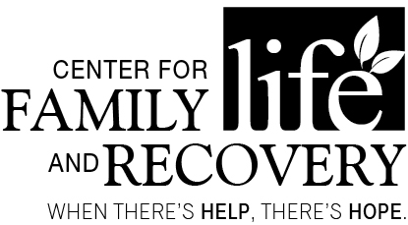

In partnership with the Professional Training Coalition of Oneida County

TRAINING OPPORTUNITY
MORNING: “Ethics in the Workplace for Helping and Addictions Professionals”
-Lee Livermore
AFTERNOON: “Recognizing Impaired Persons”
- Gary Bulinski
OASAS:
8 clock hours
Initial/Renewal
Credentialing
CPP
CPS
AM: Section 3
PM: Section 1

CASAC Renewal (both)
DATE: April 19, 2018
TIME: 8:00 A.M. - 5:00 P.M.
PLACE: Harts Hill Inn – lunch included from 12-1 P.M.
COST: $90

Participants will learn:
MORNING: The goal of this course is to introduce participants to the topic of ethics and the various types of ethics in their personal and professional environments. To help the participants understand and practice the ethical behavior.
AFTERNOON: Participants will have a basic understanding of how each drug category effects the human body, and why addiction to prescription drugs is so prevalent.
Professional
Training Committee

Bianca Bussey
Susan Calandra
Colleen Callaghan-Kirkland
Ambi Daniel
Jim Davis
Shawn Luther
Holly Matthews
Cassie McGinley
Kenan Raeljas
Sarah Rorick
Steve Smith
Denise Spagnola
Sara Wolven

Who should attend:
Social Workers, Addiction Treatment and/or Prevention Professionals, Case Managers, Residential Providers, Parole and Probation Staff, School Counselors, Marriage and Family Therapists and others serving individuals with co-occurring psychiatric and substance use disorders, and peers/peer supervisors.

Training Date/Title: “Ethics in the Workplace for Helping and Addictions Professionals/ Recognizing Impaired Persons”
REGISTRATION DEADLINE: April 17, 2018

Name: _____________________________________________ Position: ________________________________________
Agency/Employer: _________________________________ Street: ____________________________________________
City: ____________________ Zip: _________ Phone: (_____) ______________ Email: ____________________________
TO REGISTER BY Mail Only: Return form with non-refundable registration fee to: CFLR Attention: Bianca Bussey, 502 Court Street, Suite 401, Utica, NY 13502. **Registration confirmation will not be sent. Participants are considered registered when payment or P.O. number is received. Receipts for payment are available; please indicate on the form if a receipt is needed. P.O.s are accepted. You can pay online at www.WhenTheresHelpTheresHope.com. Questions? Please call 315-733-1709.
Sponsored by Oneida County
Department of Mental Health

