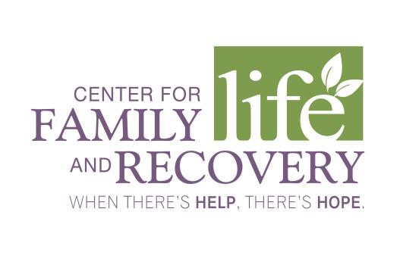
CFLR, Inc. whenthereshelpthereshope.com
502 Court St., Suite 401 Phone (315) 733-1709
Utica, NY 13502 Fax (315) 733-1789

Family Peer Advocate Job Description

Reports to: Senior Family Support Worker
Employment Status: Non-Exempt/Full Time

Qualifications:
- High School Diploma and 2-4 years of related experience in human services, education, mental health/addictions field. OMH Family Peer Credential preferred.
- Have personal experience as a recipient of mental health services and/or substance abuse services with a willingness to share personal and practical experience, knowledge, and first-hand insight to benefit clients.
- Demonstrated ability in public speaking and program delivery.
- Current and valid NYS driver’s license.

Job duties include:
- Provide Programming to families – one on one and in group setting
- Establish and build relationships with community organizations and resources relating to the agency Mission/Vision. Attend local, regional and state committee/consortium/coalition meetings as relevant.
- Demonstrate sensitivity to, and respect for, the diverse cultural backgrounds and practices of volunteers, consumers and staff.
- Compile program statistics including monthly, quarterly and annual reports.
- Provide training to volunteers and referring professionals when needed.
- Offer weekly family-friendly events throughout Oneida and Herkimer Counties;
- Convene a Peer Family Support Group.
- Provide material for website/Facebook postings and calendar updates.

Employee Signature Date

Chief Executive Officer’s Signature Date

In support of the Americans with Disabilities Act, this job description lists only those responsibilities and qualifications deemed essential to the position. Equal Opportunity Employer.

4-4-18

