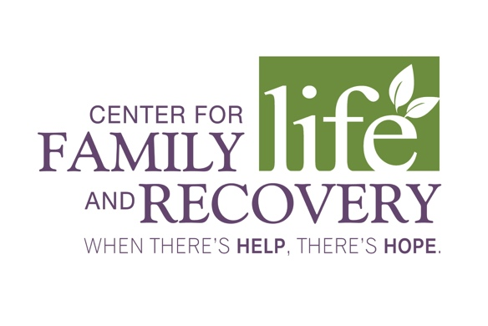

CFLR, Inc. WhenTheresHelpTheresHope.com
502 Court St., Suite 401 Phone (315) 733-1709
Utica, NY 13502 Fax (315) 733-1789
December 22, 2015

Mathew K. Higbee, Attorney at Law
Higbee & Associates
1504 Brookhollow Dr. Suite 112
Santa Ana, CA 92705

Re: Case 109624

I accordance to your request the Center for Family Life and Recovery, Inc. has removed stated image from the website as of December 21, 2015.

Center for Family Life and Recovery, Inc. is a non-profit organization and any payments as you request in the letter needs to go through an approval process of the Board of Directors as well as legal review.

Sincerely,

Cassandra Sheets
Chief Executive Officer
Center for Family Life & Recovery, Inc.
502 Court Street, Suite 401
Utica, New York 13502
Phone 315.768.2645
Fax 315.733.1789
csheets@cflrinc.org

205 N. Washington St. 414 N. James St.
Herkimer, NY 13350 Rome, NY 13440
(315) 866-8407 (315) 336-3090

