NYS Parent Portal Website and Mobile App
The NYS Parent Portal ( www.nysparenting.org) houses the four websites created by the NYS Council on Children and Families with state agency partners to help parents and caregivers. Parents, caregivers and social service professionals can help build a culture of positive parenting in our communities with the help of these resources. Use these resources to make families aware of childcare options, helpful hints to navigate concerns about development delays, and parenting support in your community.

The Council added covid-19 resources for parents on March 23rd in response to the abrupt shutdown of the state and self-isolation in our homes. During March -June 2020, the covid-19 resources page has had over 3000 visitors spending 12 minutes on average on the page. In mid- April, we added a downloadable listing with more resources for families and caregivers. We are currently in the process of updating both sets of resources.

The four websites on the NYS Parent Portal are the:
- NYS Childcare, Afterschool and Home Visiting Programs Locator
- Parent Guide
- Every Student Present
- Multiple Systems Navigator
The NYS Parent Portal is also a mobile app and is ready for download in the App Store and Google Play Store! Download it today for helpful parenting tips!

The NYS Parent Portal (www.nysparenting.org) was created as a part of the Maximizing Parent Choice and Knowledge activity of the NYSB5 initial grant awarded to the NYS Council on Children and Families. This project was made possible by grant number 90TP0059. Its contents are solely the responsibility of the authors and do not necessarily represent the official view of the United States Department of Health and Human Services, Administration for Children and Families.

Social Media Posts
Below are some “ready to post” social media blurbs that you can use on any social media platform. Be sure that you are following The Council on Twitter (@nysccf) and “like” our Facebook page (@nysccf) so we can see your post!

Post 1
You can download #TalkingisTeaching posters from the NYS Parent Portal in multiple languages! Share with the NYS Council on Children and Families how you are using the posters in your community by tagging @NYSCCF on Facebook and Twitter.
http://ow.ly/Ielh50AvnlC
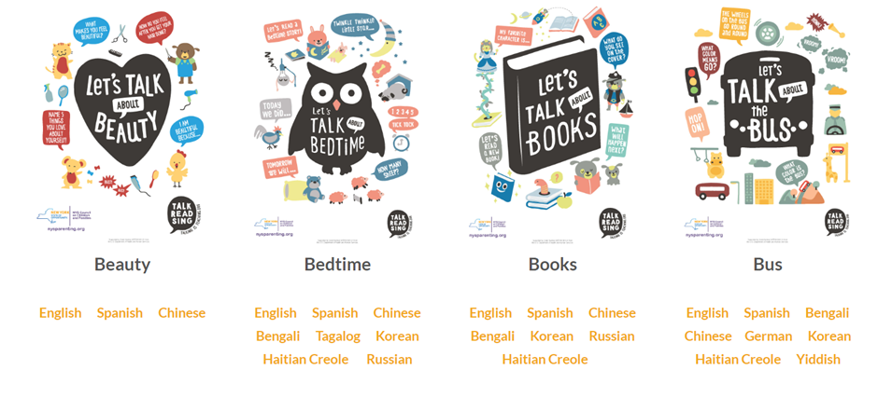

Post 2
Download the NYS Parent Portal app for helpful parenting tips in the palm of your hand! Available on Apple and Android devices by searching ‘NYS Parent Portal’ in the App Store and Google Play Store.
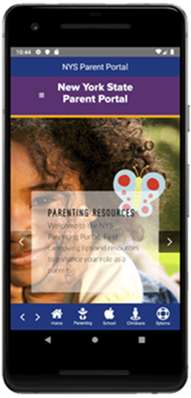

Post 3
Have you checked NYS Parent Portal app? Download the NYS Parent Portal today for helpful parenting information! Look for the blue butterfly in the App Store and Google Play Store.
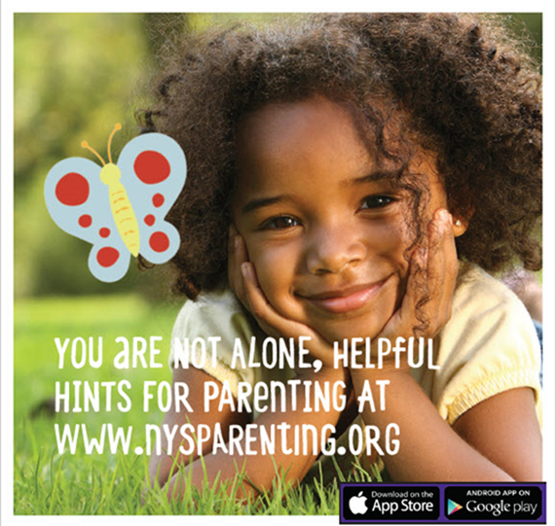

Links and Tags to include in Posts
When posting about NYS Council on Children and Families projects, please tag the Council on Children and Families @nysccf on Twitter and Facebook. Promoting NYS parenting resources can further help spread awareness and link families to the resources available to them. The NYS Parent Portal was developed to put all parenting resources in one place. The link to the NYS Parent Portal is www.nysparenting.org the mobile app is available for download in the App Store and Google Play Store.

