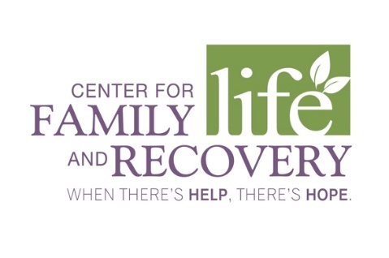

In partnership with the Professional Training Coalition of Oneida County TRAINING OPPORTUNITY

OASAS:

6 Hours

CASAC
Renewal Only

CPP/CPS

Social Work
6 Hours

“Post-Partum Depression” with James Davis (LMHC)
“Miscarriage Grief” with Linda Zelows (LCSW-R)
DATE: April 24th, 2020
TIME: 8:30AM-4:00PM

PLACE: Center for Family Life and Recovery
502 Court St. Suite 401 Utica, NY 13502
COST: $60 (lunch included)

Professional
Training Committee

Palma Brigano
Colleen Callaghan-
Kirkland
Bonnie Carr
Jennifer D’Amico
Ambi Daniel
Jim Davis
Crystal Feria
Dominica Liscio
Denise Spagnola
Heather Youda

Participants will learn:
Through participation in this training, attendees will learn about post-partum depression. Participants will learn how to identify and support post-partum depression and the tools to help those affected by it.

Who should attend:
Social Workers, Addiction Treatment and/or Prevention Professionals, Case Managers, Residential Providers, Parole and Probation Staff, School Counselors, Marriage and Family Therapists and others serving individuals with co-occurring psychiatric and substance use disorders.

--------------------------------------------------------------------------------------------------------------------------------
Training Date/Title: “Post-Partum Depression”
REGISTRATION DEADLINE: April 13, 2020

Participant: _______________________________________________________________________
Position: _________________________________________________________________________
Employer: ________________________________________________________________________
Payment type: check: _____ pay in person: _____ cc#: ___________________ ex: _ _ /_ _ ccv: _ _ _
Phone: (_____) _______________ Email: _______________________________________________

TO REGISTER: Return form with non-refundable registration fee to: Center for Family Life and Recovery, Inc., 502 Court Street, Suite 401, Utica, NY 13502. **Registration confirmation will not be sent. Participants are considered registered when payment or P.O. number is received. Receipts for payment are available – please indicate on the form if a receipt is needed. P.O.s are accepted. You can pay online at www.WhenTheresHelpTheresHope.com Questions? Please contact Dominica Liscio via email
dliscio@cflrinc.org or by phone: 315.733.1709.

Sponsored by Oneida County
Department of Mental Health

