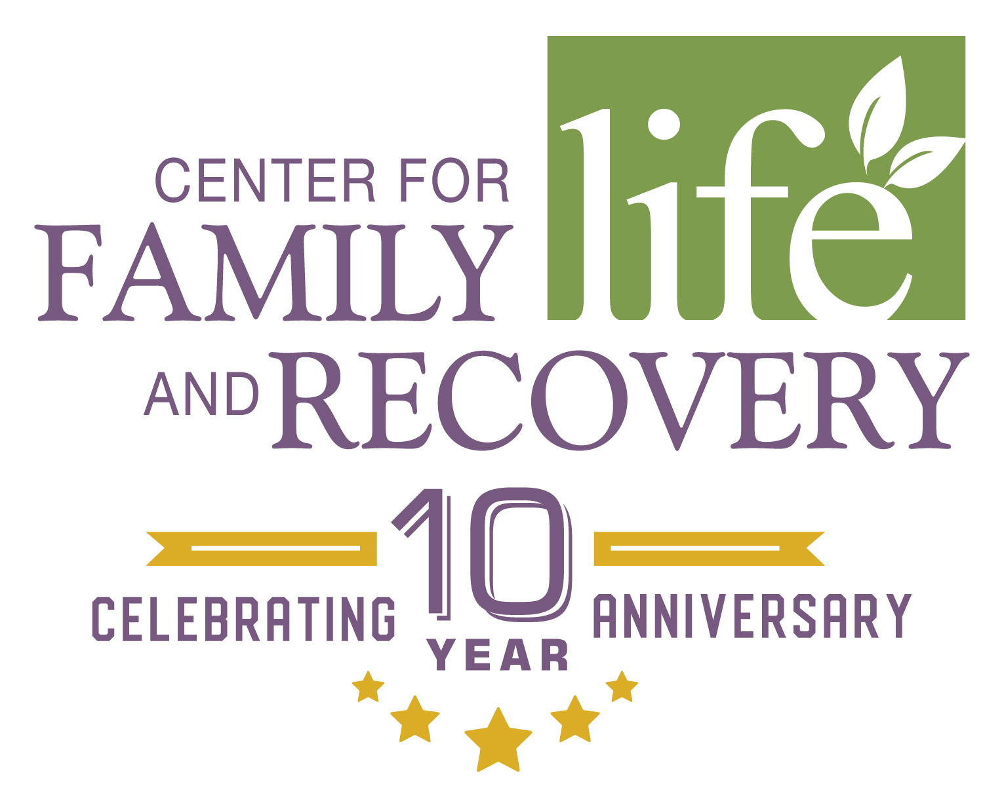

CFLR, Inc. WhenTheresHelpTheresHope.com
502 Court St., Suite 401 Phone (315) 733-1709
Utica, NY 13502 Fax (315) 733-1789

PSA: Please be advised that we received an alert from Oneida County Opioid Task Force that there is a new potential drug threat; below is the following message received:

Oneida County Opioid Task Force Members:
(Please see information below related to a new potential drug threat)
We have received reports from our partners at Mohawk Valley Health System and Helio Health of a substance that appears to be circulating in the Utica area and is causing adverse side effects for those who consume it. Details below:
- Street Name: "Up" aka “Ups” or "Tucci"
- Description: This substance is reportedly a combination of various types of synthetic drugs that are all being mixed together as one. It can be injected, snorted or smoked. Reports of it causing heightened aggression and irrational behavior for those who consume it.
- Location: Reports of people purchasing this substance from two separate convenience stores, both located on Oneida Street in Utica. Additional reports of individuals under the influence of this substance laying on the sidewalk near the convenience stores, unaware that their bodies were freezing.
Additional Information: Given the descriptions of this substance and the various side effects that have been reported, we are inclined to hypothesize that this is either a new or existing strain of synthetic marijuana. As is common with synthetic marijuana, consumption can cause heightened aggression, agitation, paranoia, etc., AND a single package may contain multiple different drugs/chemicals, which are oftentimes more dangerous in combination. These recent reports are similar in nature to the reports we received in the fall of 2020 and included

If you or a loved one are in need Prevention Services and Programming and/or Narcan Training, please contact Heather Youda, Community Prevention Educator at 315-768-2661 or hyouda@cflrinc.org to set up a training. All Narcan trainings come with a Narcan Kit and NYS Certified Certificate.

If you would like to know more about the Center for Family Life and Recovery and what services we provide, go to https://www.WhenTheresHelpTheresHope.com/prevention.

Stay Safe and Healthy!

Jodi Warren and the CFLR Prevention Team
Director of Prevention Services
jwarren@cflrinc.org
315-768-2643

205 N. Washington St. 510 Erie Blvd. West
Herkimer, NY 13350 Rome, NY 13440
(315) 866-8407 (315) 336-3090

